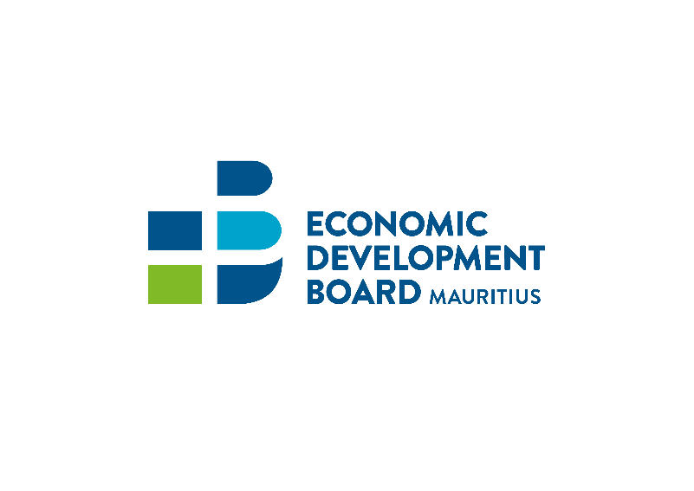

Africa Warehousing Scheme (AWS) for Tanzania
Registration Form
Name of Company | :
Business Registration Number (BRN) | :
VAT No. | :
TAN No. | :
Address | :
Contact Person | :
Designation | :
Telephone | :
Mobile | :
Fax | :
Email | :
Website | :
Product(s) manufactured in Mauritius | :
Export products - Description and HS Code(s) | :
List of products to be warehoused in Tanzania | :
Date: …………………………………. |  | Signature: ……………………………………………….
Company Seal |  | Designation: …………………………………………….

CAUTION
The Economic Development Board (EDB) Mauritius reserves the right to exercise control post disbursement of fund and in case any fraudulent declaration is detected the following may apply:
1) The company will not be eligible for any future rebate, and
2) Legal action will be undertaken to recover the amount refunded and may be also liable to prosecution.

